Name:P.Gayathri
Reg.No:192424324

7. Write the Python program to implement Travelling Salesman Problem (TSP).

Aim:

To write a Python program to implement the Travelling Salesman Problem (TSP) and find the minimum travelling cost and the optimal path.

Algorithm:

Step 1: Start the program.

Step 2: Enter the number of cities.

Step 3: Read the cost matrix of all cities.

Step 4: Generate all possible paths using permutations.

Step 5: Calculate the total travelling cost for each path.

Step 6: Compare the costs of all paths.

Step 7: Store the path having the minimum cost.

Step 8: Display the minimum travelling cost and optimal path.

Step 9: Stop the program.
PROGRAM:
n = 4
cost = [
[0, 10, 15, 20],
[10, 0, 35, 25],
[15, 35, 0, 30],
[20, 25, 30, 0]
]
visited = [False] * n
visited[0] = True
best_cost = float('inf')
best_path = []
def tsp(city, count, total_cost, path, prefix=""):
global best_cost, best_path
if count == n:
final_cost = total_cost + cost[city][0]
print(prefix + "└── City 1 (Return)")
if final_cost < best_cost:
best_cost = final_cost
best_path = path + [0]
return
unvisited = []
for i in range(1, n):
if not visited[i]:
unvisited.append(i)
for index, next_city in enumerate(unvisited):
is_last = (index == len(unvisited) - 1)
if is_last:
branch = "└── "
new_prefix = prefix + " "
else:
branch = "├── "
new_prefix = prefix + "│ "
print(prefix + branch + "City " + str(next_city + 1))
visited[next_city] = True
tsp(
next_city,
count + 1,
total_cost + cost[city][next_city],
path + [next_city],
new_prefix
)
visited[next_city] = False
print("\nTSP SEARCH TREE")
print("================")
print("City 1")
tsp(0, 1, 0, [0])
print("\n================")
print("Minimum Cost =", best_cost)
print("Best Path =", end=" ")
for i, city in enumerate(best_path):
print("City", city + 1, end="")
if i < len(best_path) - 1:
print(" -> ", end="")
print()

OUTPUT:
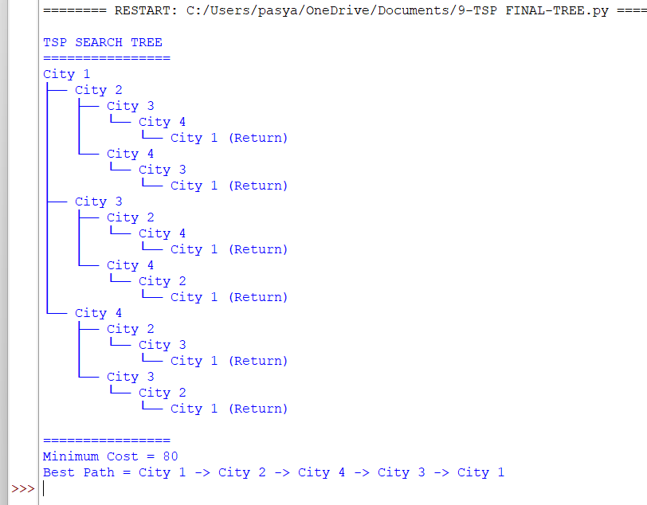

RESULT:
Thus, the Python program to implement the Travelling Salesman Problem (TSP) was executed successfully, and the minimum travelling cost and optimal path were obtained.

